Tonight's Cast
Pre-Show Brandon
Trixie Danielle
Frank N. Furter Jesus
Brad Majors Bill

Janet Weiss Anne

Riff Raff Elfboy
Magenta Liz
Columbia Stezzy
Dr. Scott Tim
Eddie Tracy
Rocky Garrett
Crim Courtney
Phantom Dan/Elfboy

Transylvanians
Cheryl Jesus Poncho Larry CJ Terry Kim Adam

Midnight Mafioso
Producer: Mark Tomaino
Asst. Producers: Brandon, Colleen
Tranny Coordinator: Cheryl
Photographer: Aleah
Webmaster: Bill
Spotlights: Andrew, Travis, Kim, Sam, Shaun
Props Fox: Jo Muu
Scenic Tech: Kyle, other Zack, Paco and Garett
Security: Glenn. Shevaun, Kiem
VooDooPin.com Buttons Pins Magnets
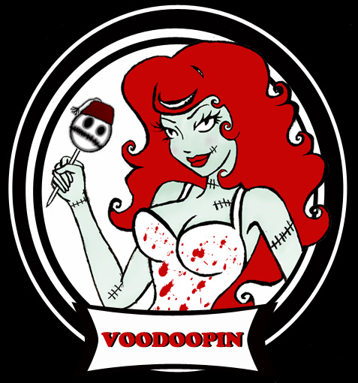 Just the coolest.

Denton Times
Psychobilly Beach Party AUGUST 23 BE HERE! Watch CRYBABY for theme ideas.

ALSO Do not forget our annual most special Lingerie Night of ALL I September: Catholic School Girl Lingerie Night. The last Saturday of every month is Lingerie Night but Bill’s Birthday brings out something very naughty in plaid.

Other theme nights upcoming: Pimp and Hooker, 80s Night and Side Show Freak Night. Stay tuned.

How to get tickets: Did you know you can get tickets online? Tix.com keyword Rocky Horror OR Paypal through the MI website. Of course you can always buy at the door…but if you ever need to use a credit card or want to spend your paypal money…those are some good ways. Thank you as always for supporting our nasty little habit.

Wow…the audience is ready for the stage too!

Midnight Insanity
(562) 235-8053
www.midnightinsanity.com
E-mail: (any cast member's name)@midnightinsanity.com
