Tonight's Cast
Pre-Show Brandon Tracy
Trixie Ann
Frank N. Furter Diego
Brad Majors Bill

Janet Weiss Courtney

Riff Raff Elfboy
Magenta Liz
Columbia Stezzy
Dr. Scott Tim
Eddie Wade
Rocky Garrett
Crim Zach
Phantom Dan/Elfboy

Transylvanians
Cheryl Jesus Poncho Larry CJ Terry Kim Adam

Midnight Mafioso
Producer: Mark Tomaino
Asst. Producers: Brandon, Colleen
Tranny Coordinator: Cheryl
Photographer: Aleah
Webmaster: Bill
Spotlights: Andrew, Travis, Kim, Sam, Crystal
Other tech Shawn. Leaf
Props Fox: Jo Muu
Scenic Tech: Kyle, other Zack, Paco and Garett
Security: Glenn. Shevaun, Kiem
VooDooPin.com Buttons Pins Magnets
 Just the coolest.

Denton Times

NEXT WEEK our monthly Lingerie Night.

ALSO Do not forget our annual most special Lingerie Night of ALL I September: Catholic School Girl Lingerie Night. The last Saturday of every month is Lingerie Night but Bill’s Birthday brings out something very naughty in plaid.

Other theme nights upcoming: Pimp and Hooker, 80s Night and Side Show Freak Night. Stay tuned.

How to get tickets: Did you know you can get tickets online? Tix.com keyword Rocky Horror OR Paypal through the MI website. Of course you can always buy at the door…but if you ever need to use a credit card or want to spend your paypal money…those are some good ways. Thank you as always for supporting our nasty little habit.

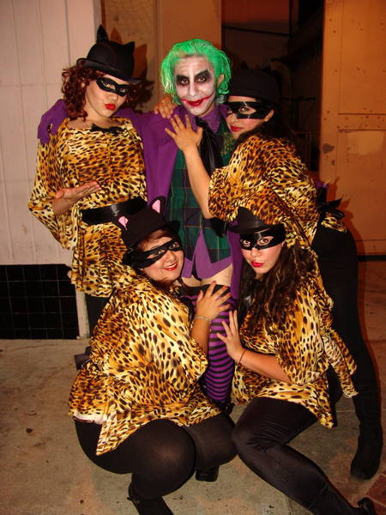
Midnight Insanity (562) 235-8053
www.midnightinsanity.com
E-mail: (any cast member's name)@midnightinsanity.com

