Tonights Cast for HOMO HORROR
Preshow Brandon
Trixie Anne
Frank Diego
Brad Bill

Janet Courtney

Riff Brandon
Magenta Colleen
Columbia Stezy
Dr. Scott Backdoor Zach
Eddie Mark
Rocky Eddie
Crim Zachhhh
Phantom Dan

Trannys
Cheryl Jesus Poncho Larry CJ Terry Kim Adam Jordan Kristi Carlos

Midnight Mafioso
Producer: Mark Tomaino
Asst. Producers: Colleen, Brandon
Tech Director Steffan Photographer: Aleah
Webmaster: Bill Tranny coordinator: Cheryl
Tech: Andrew Shawn Travis Kim Sam Crystal Leif
Kyle Zach Paco Garett
Security: Shweet Harmless Shevaun, Alina, Glenn
Props Fox Jo Muu and Sara Le’evil
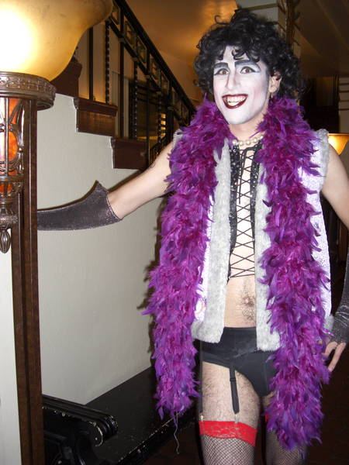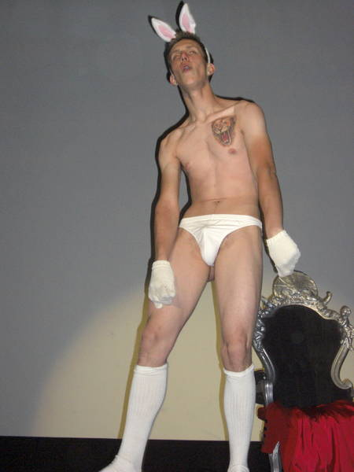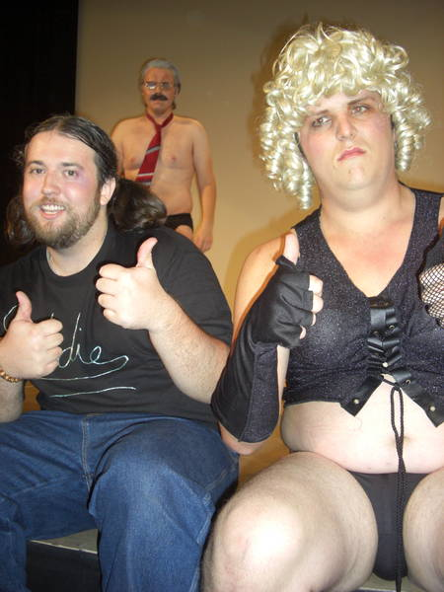
Steffan as Frank Gerritt as Trixie Leif Larry and Zack
in the back
Denton Times

Return to Normal? Well after last weeks homo horror show you might say that. But at Midnight Insanity..we never stop asking “what if?” Like what if the girls were boys, boys were girls, they all were bi and what would it be like if we did the show like we were high? What if Goths dressed in pastel and what if everyone was a pimp or a hooker and what if we hung Trixie in mid air. The one difference is, with MI, it never stops at stupid questions. We have to follow them up with Theme Nights. Like last weeks homo horror. Then we ask ourselves “What if we print these disturbing pictures in the program?”. Will that induce increased interest and attendance or just vomiting? Well…one more question we ask ourselves…”What if we gave a shit!” More attendance. Spontaneous projectile expectoration. Is there really a difference? And WHAT IF we did not bring these sick and lame ideas to the stage? Then who would?
Check out the new shirts in the lobby. These are an MI original design. We have long and short sleeve…pocket and no pocket…extended sizes and a few specialty items like an MI jogging suit and some button downs and a denim jacket with the new graphics on he back. Check them out. Shirts start at $5.
NEW CALENDAR FOR WARNER GRAND: Check out WarnerGrandShows.com for upcoming shows here.
LOSE YOUR PROGRAM?: Each week under images we upload pix from that weeks show. Now we are also uploading these programs so you can download and print or save or read them at your leisure and stay up to date on Rocky news.
Did you know you can get tickets online? Tix.com keyword Rocky Horror OR Paypal through the MI website. Of course you can always buy at the door…but if you ever need to use a credit card or want to spend your paypal money…those are some good ways. Thank you as always for supporting our nasty little habit.
FOR A GOOD TIME JOIN: Hey…everybody on stage was an audience member. If you want to join don’t be bashful. Talk to any cast member. Start slow and work your way on stage, or be in a non stage related role if you wish (DO NOT JOIN JUST FOR FREE ADMISSION this is WORK!)

Midnight Insanity (562) 235-8053 (MARK) MidnightInsanity.com

