The Rules
2. No smoking in the theater (If you're just flaming, join cast).
2. Please be AS LOUD AS YOU FUCKING WANT (when you’re inside)
2. This is an audience participation movie...
2. Do not throw anything period
2. Stay off the stage
2. If you have a penis, use the men's room. If you have a vagina, use the ladies room. If you've got both, piss on someone of your liking.
2. No double sitting in the seats or standing on them
2. No food or beverages allowed in the auditorium. Eat and Drink in lobby.
2. These bee-oo-tiful costumes? We made them. Don’t tear them apart.
2. This is a Rated-R movie. That means, if you're easily offended, we've got five words for you: Get The Fuck Out, Bitch.
SpiritHonda.com
(888) 250-5557
Mark Tomaino
Sales Manager
RHPS Discounts!
Ask for ROCKY DISCOUNT
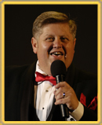

DISCLAIMER:
All photos reprinted without permission or consent in writing or otherwise express. All references to any person, animal, place or thing living or dead is purely intentional and should be construed as a personal, verbal or physical assault on the habeus corpus of the intended or even only simply mentioned, referenced subject even if implied or construed. Midnight Insanity is not responsible for the actions of the audience, the cast members, the people of San Pedro or even their own actions. Attend at your own peril. Enter at your own risk. Come see Urinetown check theater poster for schedule and see upcoming Batboy the Musical.

THIS DECEMBER: THE NUT CRACKER…Sweeeeeeeeet!!!

© Copyright Midnight Insanity, Inc. 1988-2008 and beyond
The Rocky Horror Picture Show
And 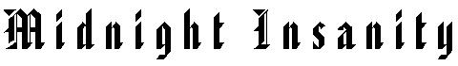
Show No. 1,163 October 18, 2008

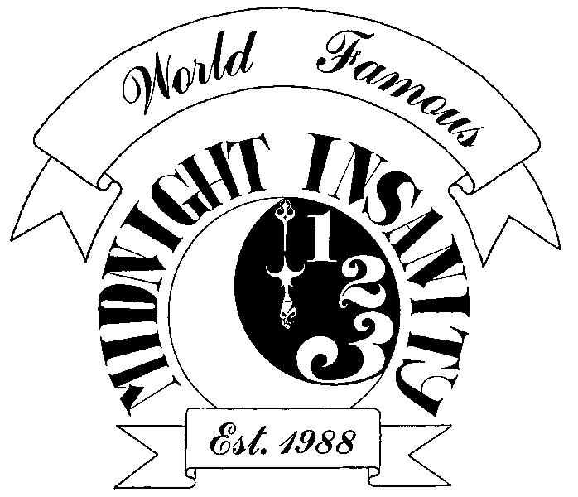

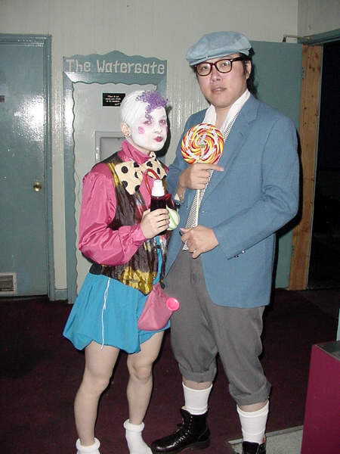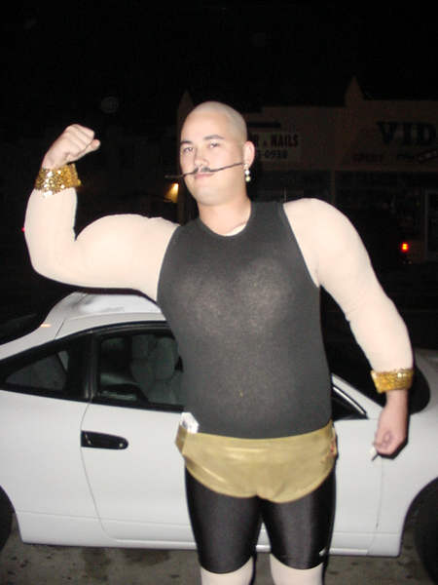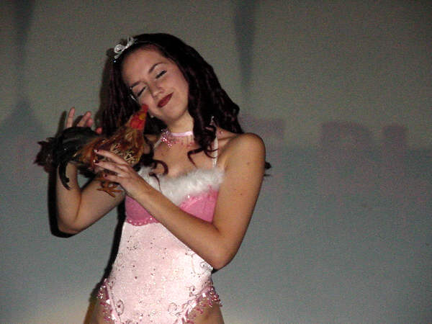
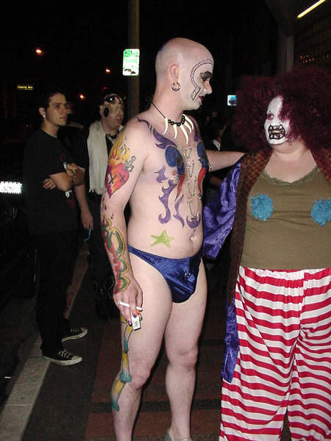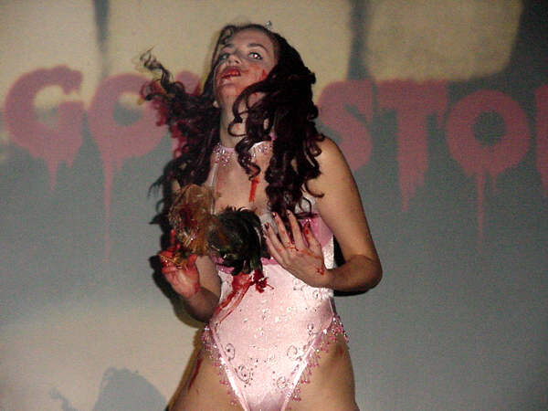
Every Saturday at the
WARNER GRAND THEATER SAN PEDRO
Its FREAKY HORROR TIME!!!

