Freak show Lineup
Barkers Tracy/Brandon
Siamese Twins Anne and Danielle
Half and Half Frank
Rube #1 Bill

Rube #2 Courtney

Wildman Elfboy
Fortune Teller Gypsy Rose Colleen
Bird Lady Stezy
FatMan Travis
Dog Boy Wade
Worlds Strongest Man Eddie
Talking Head Zach
Creepy Carnies Dan and DIego

Killer Crowns
Cheryl Jesus Poncho Larry CJ Terry Kim Adam Jordan Kristi Carlos

Midnight Mafioso
Producer: Mark Tomaino
Asst. Producers: Colleen, Brandon
Tech Director Steffan Photographer: Aleah
Webmaster: Bill Tranny coordinator: Cheryl
Tech: Andrew Shawn Travis Kim Sam Crystal Layff
Jo Muu, Kyle, other Zach, Paco and Garett
Security: Shevaun Glenn Alina
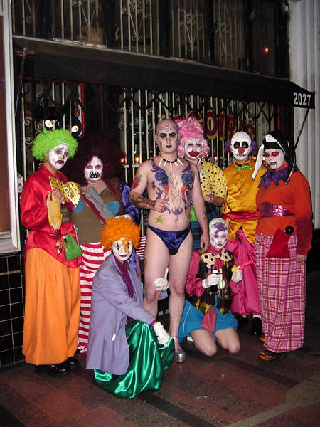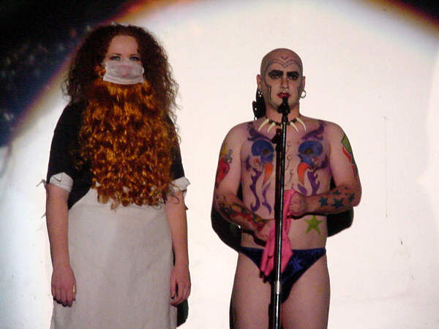

Denton Times

Welcome to the return of Freak Horror, absent 6 years now on display tonight for your wonder and amazement.

Lingerie/HALLOWEEN SHOW 10/25.

Dia de los Muertas 11/1 Come dead.

NEW CALENDAR FOR WARNER GRAND: Check out WarnerGrandShows.com for upcoming shows here at the Warner Grand including the Motown Oldies Love Jamm, Batboy the Musical and the Rocky Horror Show (The live stage play.)

LOSE YOUR PROGRAM?: Each week under images we upload pix from that weeks show. Now we are also uploading these programs so you can download and print or save or read them at your leisure and stay up to date on Rocky news.

Did you know you can get tickets online? Tix.com keyword Rocky Horror OR Paypal through the MI website. Of course you can always buy at the door…but if you ever need to use a credit card or want to spend your paypal money…those are some good ways. Thank you as always for supporting our nasty little habit.

FOR A GOOD TIME APPLY JOIN: Hey…everybody on stage was an audience member. If you want to join don’t be bashful. Talk to any cast member. Start slow and work your way on stage, or be in a non stage related role if you wish (DO NOT JOIN JUST FOR FREE ADMISSION this is WORK!)

Midnight Insanity (562) 235-8053 (MARK) www.midnightinsanity.com

