Tonight's Cast
Pre-Show Brandon
Trixie Kim
Frank N. Furter Diego
Brad Majors Bill

Janet Weiss Anne

Riff Raff Brandon
Magenta Terry
Columbia Danielle
Dr. Scott Tim
Eddie Wade
Rocky Garrett
Crim Courtney
Phantom Dan and sometimes Elfboy

Transylvanians
Cheryl Jesus Poncho Larry CJ Terry Kim Adam Kristi

Midnight Mafioso
Producer: Mark Tomaino
Asst. Producers: Brandon, Colleen
Tranny Coordinator: Cheryl
Tech Director Slash, Carlos (not really just no place to put him)
Photographer: Aleah
Webmaster: Bill
Lighting: Andrew Shawn Travis Kim Sam Crystal Layff
Props Fox: Jo Muu
Scenic Tech: Kyle, other Zack, Paco and Garett
Security: Glenn Shevaun Kiem

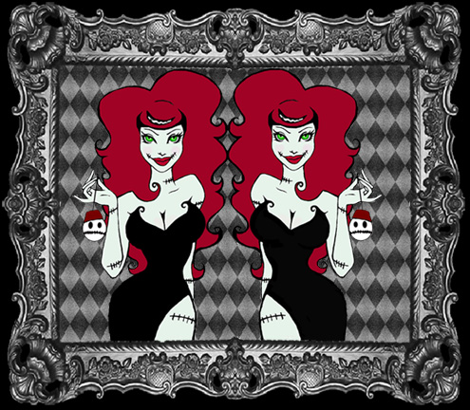
VooDooPin.com

Keychains
Buttons
Magnets
Custom items

Denton Times

Happy Birthday to Me
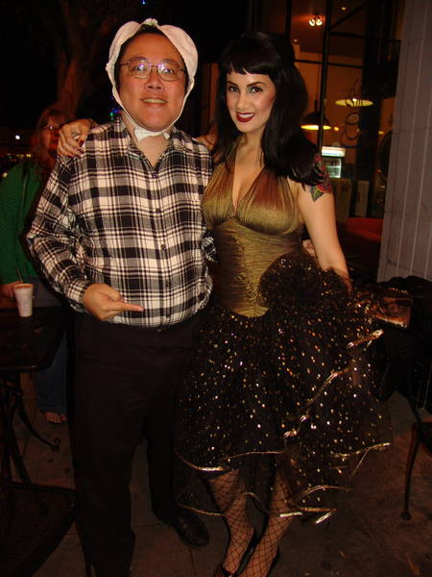
NEXT WEEK
Naughty in Plaid
Catholic School Girl Lingerie Night AND Bill’s Birthday show
Other theme nights upcoming: Pimp and Hooker, Monster Horror, Side Show Freak Night. Stay tuned for dates.

THEY’RE COMING TO TAKE US AWAY
HA HA HO HO HEE HEE
ROADSHOW October 16, Thursday 9PM MIDNIGHT INSANITY PRESENTS Rocky Horror at Cal State Channel Islands, formerly the Camarillo State Mental Institution. This facility is the subject of the song Hotel California and the site of REAL Shock Treatment Research. All MI Audience are invited for free so you will be able to say you went to college and be telling the truth..well for at least ONE day. Much of the place is unmodified so we might find some interesting places.

How to get tickets: Did you know you can get tickets online? Tix.com keyword Rocky Horror OR Paypal through the MI website. Of course you can always buy at the door…but if you ever need to use a credit card or want to spend your paypal money…those are some good ways. Thank you as always for supporting our nasty little habit.

FOR A GOOD TIME APPLY HERE: Hey…nobody up there on stage was not at one time an audience member. If you think you want to be involved in any way….don’t be bashful. Talk to a cast member. You can start slow and work your way on stage, or be on security or tech or a non stage related role if that is not your thing, you still get invited to the parties and free admission (DO NOT JOIN JUST FOR FREE ADMISSION).

Midnight Insanity (562) 235-8053
www.midnightinsanity.com
E-mail: (any cast member's name)@midnightinsanity.com

