Tonight's Cast
Pre-Show Tracy and Tim
Trixie Sara Lee
Frank N. Furter Diego
Brad Majors Bill
Janet Weiss Megan
Riff Raff Elfboy
Magenta Terry
Columbia CJ
Dr. Scott Travis
Eddie Wade
Rocky Jason
Crim Larry
Phantom Paco

Transylvanians
Cheryl Ponchita Jesus Adam Sam
Ami Jordan Patti Andrew Peter Carlos

Midnight Mafioso
Producer: Mark Tomaino Assistant Producer: Brandon
Technical Director: Elfboy Webmaster: Bill
Tranny Coordinator: Cheryl Props Fox: Jo Terry
Lightboard: Gayson Photog/Secretary: Aleah
Merchandise: C.J Security Czar Shevaun
Spotlights: Drew, Mit, Taylor, Kim, Leif
Tech: Alysha, Strayson, Zac, Tracy,

V.I.S.C.I.O.U.S.
(Very Intimidating security Crew In Our Ubiquitous Service)
Shevaun Wade Beka
Last Weeks Winner
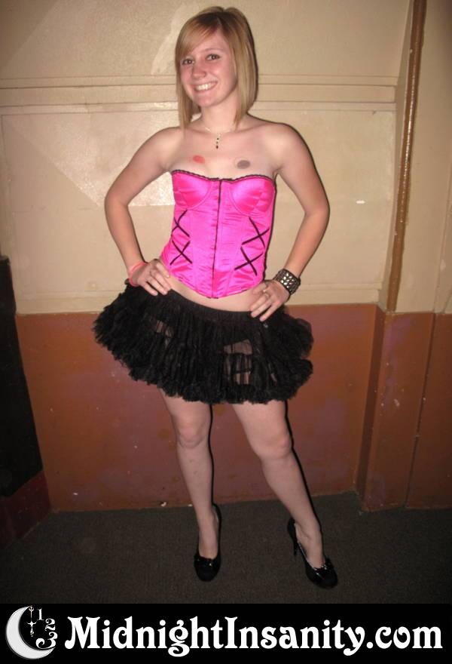
Denton Times
NO SHOW NEXT WEEK due to the Nutcracker. If you are interested in Nutcracker please come see it that weekend as it is festive and season appropriate and combines the words “Nut” and “Crack”. That should be reason enough to come see the San Pedro City Ballet Production. Check out therelevantstage.com for upcoming WGT shows of Christmas Carol, also season appropriate and starring WGT House Manager Ray Buffer (Go look at him right now..he is on his laptop in the lobby) as Scrooge and say “Hi…SCREWGE.”

BE HERE THE FOLLOWING WEEK FOR DYKEY HORROR!!!! If Homo-Horror is a Sausage fest..then Dykey Horror is a Melon Fest, or a well…you get the idea. Anyway..it is hours and hours of HOT at the Warner Grand. So come and see our girls do the whole show…we should charge extra but we won’t.

TWENTY SECOND ANNIVERSARY: Birthday Show January 16, 2010. We are making special preparations for a never before seen special unique original number before the show just for your entertainment. Come see the Alumni and the old friends who show to celebrate and bring cake. We need cake.

Filming for the Blue Ray release of Rocky Horror (Cast theater scenes and starring our props and some of our cast members) has been pushed back to January. And speaking of January..be sure and be here for our 22nd Anniversary show, JANUARY 17TH. There will be a special original performance of something cool we are working on as you speak. Are you speaking?

Go to MidnightInsanity.com to link up to our myspace, twitter, Facebook, Rocky Horror Yellow Pages list and see pix of yourselves each week.

Please see a castmember if you would like to join cast and are not a Douche. If you are a Douche please go to some other midnight flick.

Dykey Horror 2009
Frank-Anne, Riff-Stezzy, Magenta-Courtney Columbia- Sara Lee
