Tonight's Cast
Pre-Show Brandon and Dan
Trixie Shevaun
Frank N. Furter Sara Lee
Brad Majors Colleen
Janet Weiss CJ
Riff Raff Anne
Magenta Sammie
Columbia Jordan
Dr. Scott Terry
Eddie Kim
Rocky Megan
Crim Jeselyn
Phantom Danielle

Transylvanians
Cheryl Ponchita Jesus Adam Sam
Ami Jordan Patti Andrew Peter Carlos

Midnight Mafioso
Producer: Mark Tomaino Assistant Producer: Brandon
Technical Director: Elfboy Webmaster: Bill
Tranny Coordinator: Cheryl Props Fox: Jo Terry
Lightboard: Gayson Photog/Secretary: Aleah
Merchandise: Christiana Security Czar Shevaun
Spotlights: Drew, Mit, Taylor, Kim, Leif
Tech: Alysha, Strayson, Zac, Tracy,

V.I.S.C.I.O.U.S.
(Very Intimidating security Crew In Our Ubiquitous Service)
Shevaun Wade Beka

Denton Times

Happy Holidays Merry Christmas Chappy Channukah Merry Kwanza Happy Ramadan and most importantly only roughly 300 days til’ Halloween and counting. Welcome to the Clam Fest we call DYKEY HORROR!!!!

BE HERE for our TWENTY SECOND BIRTHDAY Show January 16, 2010. We are making special preparations for a never before seen special unique original number before the show just for your entertainment. Come see the Alumni and the old friends who show to celebrate and bring cake. We need cake.

Filming for the Blue Ray release of Rocky Horror, featuring some MI cast members and our larger props will happen in January. During our birthday show Fox will be sending trucks to the Warner Grand to pick up our props for loan immediately after the show.

Go to MidnightInsanity.com to link up to our myspace, twitter, Facebook, Rocky Horror Yellow Pages list and see pix of yourselves each week.

From the UCLA Film & Television Archive: “Warner Bros. Motion Picture Imaging (MPI) operates one of the entertainment industry’s foremost state-of-the-art digital post production and restoration facilities, providing services such as digital intermediate, scanning, color correction, dirt and scratch removal and film recording….MPI has developed a unique and patented process to digitally restore classics such titles as The Godfather, Gone with the Wind, The Wizard of Oz, North by Northwest, and The Rocky Horror Picture Show. WHAT? Well…Rocky made SOMEBODY’s Fave Five!!!

Ask a cast member how to join. If you were in cast now you would have been to two huge parties this week, partyie tonight at the show, then get up tomorrow and go to yet ANOTHER party. We are not at liberty to tell you what all transpired at these parties but we can tell you this: Whole lot of “baking” going on.

NEXT WEEK is Lingerie Night..the day after Christmas come get your jollies all over again.
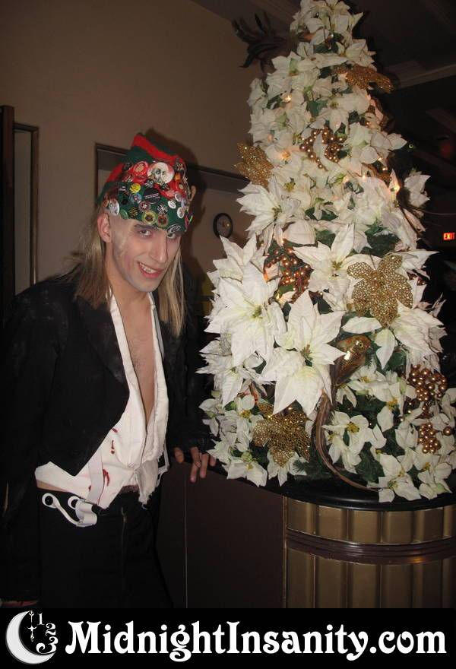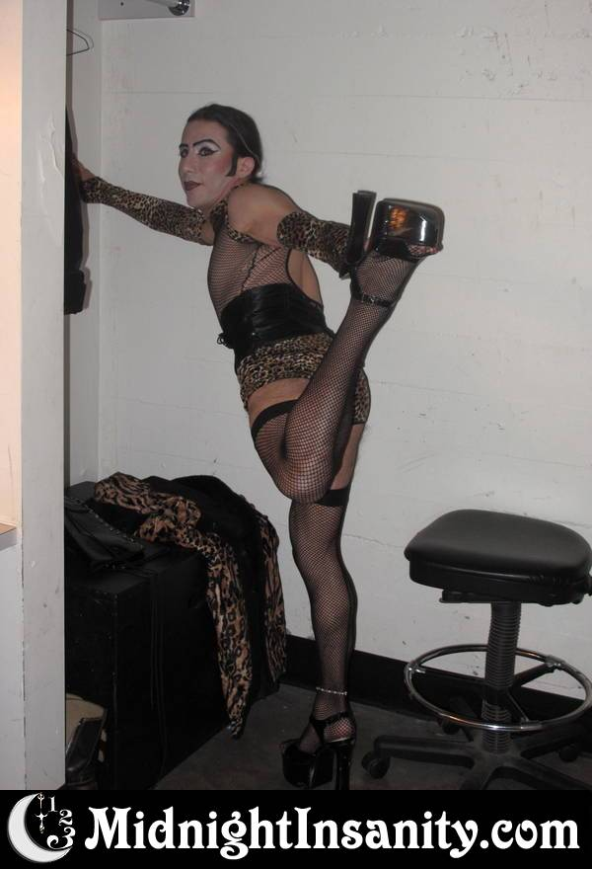
Elfboy wishing you Diego wishing you
Happy Holidays Happy Holidays

