The Rules
2. No smoking in the theater (If you're just flaming, join cast).
2. Please be AS LOUD AS YOU FUCKING WANT (when you’re inside)
2. This is an audience participation movie...
2. Do not throw anything period
2. No Lighters lit during film
2. If you have a penis, use the men's room. If you have a vagina, use the ladies room. If you've got both, piss on someone of your liking.
2. No double sitting in the seats or standing on them
2. No food or beverages allowed in the auditorium. Eat and Drink in lobby.
2. These bee-oo-tiful costumes? We made them. Don’t tear them apart.
2. This is a Rated-R movie. That means, if you're easily offended, we've got five words for you: Get The Fuck Out, Bitch.
SpiritHonda.com
(888) 250-5557
Mark Tomaino
Fleet Manager
RHPS Discounts!
 Ask for the MI DISCOUNT
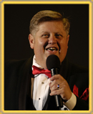

DISCLAIMER
Photos reprinted without permission, consent in writing or otherwise expressed. References to any person, animal, place or thing living or dead is purely intentional and should be construed as a personal, verbal or physical assault on the habeus corpus of the intended or even only simply mentioned, referenced or implied subject however construed. MI is not responsible for the actions of the audience, the cast members, the people of San Pedro or even their own actions. Attend at your own peril. Enter at your own risk. Exit only at the rear. Do you have any tattoos?

© Copyright Midnight Insanity, Inc. 1988-2009 and beyond
The Rocky Horror Picture Show
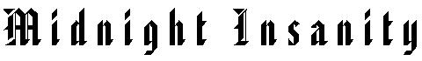
Show No. 1,176 January 17, 2009

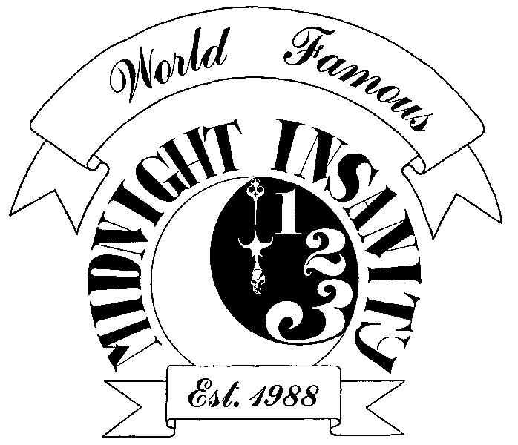

Midnight Insanity 21st Anniversary Show
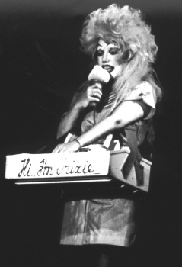
Special Guest Jamie Donnelly
Star of Grease and the Original RHS Trixie

Warner Grand Theater
San Pedro CA

