Tonights Cast
Pre Pre Show Mark Tomaino
Special Guest Jamie Donnelly
Preshow Tracy, Brandon
Trixie Anne
Frank Diego
Brad Bill

Janet Courtney

Riff Elfboi
Magenta Kristi
Columbia Danielle
Dr. Scott Tim
Eddie Mark
Rocky Eddie
Crim Courtney
Phantom Dan

Trannys
Cheryl Jesus Poncho Larry CJ Terry Kim Adam Jordan Kristi Carlos

Midnight Mafioso
Producer: Mark Tomaino
Asst. Producers: Colleen, Brandon
Tech Director Steffan Photographer: Aleah
Webmaster: Bill Tranny coordinator: Cheryl
Tech: Andrew Shawn Travis Kim Sam Crystal Leif
Kyle Zach Paco Garett
Security: Shweet Harmless Shevaun, Alina, Glenn
Props Fox Jo Muu and Sara Le’evil
Midnight Insanity (562) 235-8053 (MARK) MidnightInsanity.com
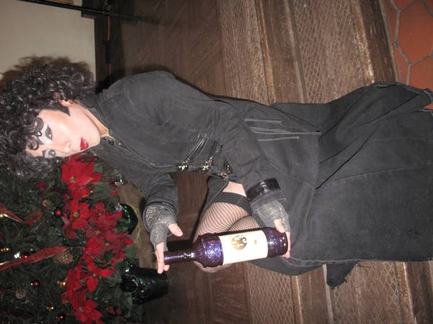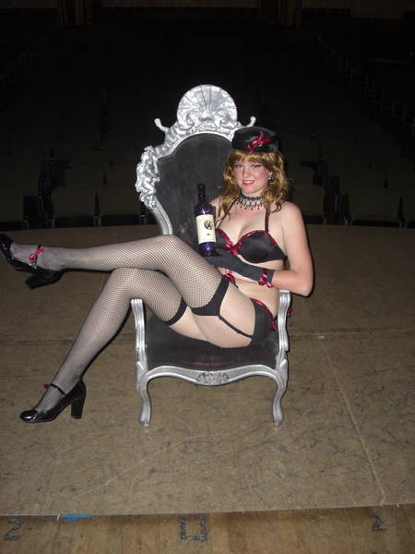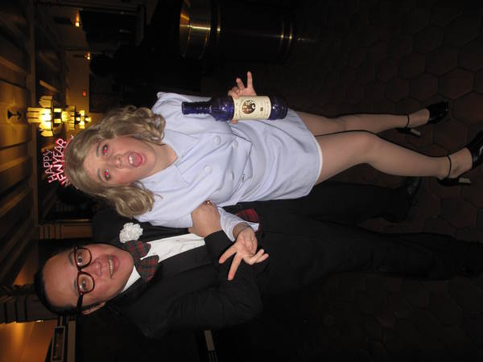

Denton Times
Thanks for coming tonight. Be here next week for our 21st anniversary show. We will have a special original number we will be performing before the movie that we are choreographing solely for this event.

Check out the new shirts in the lobby. These are an MI original design. We have long and short sleeve…pocket and no pocket…extended sizes and a few specialty items like an MI jogging suit and some button downs and a denim jacket with the new graphics on he back. Check them out. Shirts start at $5.

NEW CALENDAR FOR WARNER GRAND: Check out WarnerGrandShows.com for upcoming shows here.

LOSE YOUR PROGRAM?: Each week under images we upload pix from that weeks show. Now we are also uploading these programs so you can download and print or save or read them at your leisure and stay up to date on Rocky news.

Did you know you can get tickets online? Tix.com keyword Rocky Horror OR Paypal through the MI website. Of course you can always buy at the door…but if you ever need to use a credit card or want to spend your paypal money…those are some good ways. Thank you as always for supporting our little habit.

FOR A GOOD TIME JOIN: Hey…everybody on stage was an audience member. If you want to join don’t be bashful. Talk to any cast member. Start slow and work your way on stage, or be in a non stage related role if you wish (DO NOT JOIN JUST FOR FREE ADMISSION this is WORK!)

