Tonights Cast
Preshow Tracy
Trixie Kim
Frank Diego
Brad Kyle

Janet Courtney

Riff Paco
Magenta Colleen
Columbia Chelsea
Dr. Scott Travis
Eddie Wade
Rocky Brandon
Crim Courtney
Phantom Dan

Trannys
Cheryl Poncho Larry Terry Kim Adam Jordan Kristi Carlos

Midnight Mafioso
Producer: Mark Tomaino
Asst. Producers: Colleen, Brandon
Tech Director Steffan Photographer: Aleah
Webmaster: Bill Tranny coordinator: Cheryl
Tech: Andrew Travis Kim Sam Crystal Leif
Kyle Zach Paco Garett
Security: Shevaun, Alina, Glenn, Shawn
Props Fox Jo Muu and Sara Le’evil
Midnight Insanity (562) 235-8053 (MARK) MidnightInsanity.com

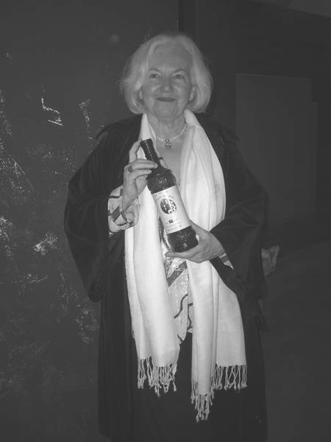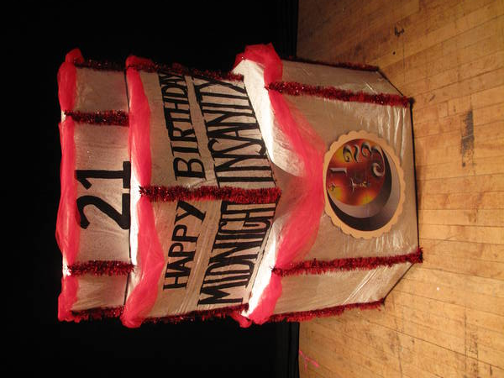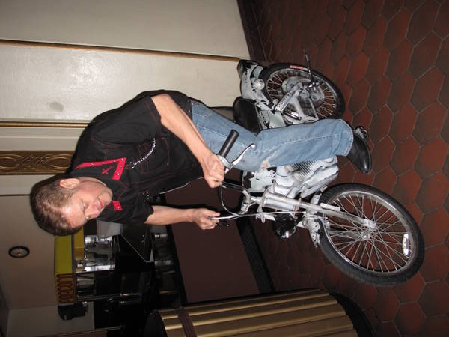
Jamie Donnelly Carbohydrate Paper Route Practice

Denton Times
Thanks for helping us celebrate our 21st cast anniversary last week. Thanks to Grease and RHS start Jamie Donnelly for being FABULOUS. She loved you too.

Check out the new shirts in the lobby. These are an MI original design. We have long and short sleeve…pocket and no pocket…extended sizes and some button downs and a denim jacket with the new graphics on he back. Check them out. Shirts start at $12.

NEW CALENDAR FOR WARNER GRAND: Check out WarnerGrandShows.com for upcoming shows here.

LOSE YOUR PROGRAM?: Each week under images we upload pix from that weeks show. Now we are also uploading these programs so you can download and print or save or read them at your leisure and stay up to date on Rocky news.

Did you know you can get tickets online? Tix.com keyword Rocky Horror OR Paypal through the MI website. Of course you can always buy at the door…but if you ever need to use a credit card or want to spend your paypal money…those are some good ways. Thank you as always for supporting our little habit.

WILL HE MAKE IT TIL’ THEN? Bill will be celebrating his 20th anniversary in Rocky on June 30. If he lasts that long. Someone get the Ensure.

FOR A GOOD TIME JOIN: Hey…everybody on stage was an audience member. If you want to join don’t be bashful. Talk to a cast member. Start slow (joining..not talking) and work your way onstage, or be in a support role if you wish (DO NOT JOIN JUST FOR FREE ADMISSION this is WORK dammit ! )

