The Rules
2. No smoking in the theater (If you're just flaming, join cast).
2. This is an audience participation movie...
2. Do not throw anything at the stage, the screen, or the thespians.
2. If you have a penis, use the men's room. If you have a vagina, use the ladies room. If you've got both, piss on Waaade.
2. No double sitting in the seats.
2. Do not park in the parking lots after two. You might be towed.
2. This is an Rated-R movie. That means, if you're easily offended, we've got five words for you: Get The Fuck Out, Bitch.
Ask for the ROCKY HORROR Discount at
GardenaHonda.com
800-965-7571
Ask for Mark Tomaino, Client Service Director
15541 S. Western Ave Gardena CA


BULLETIN: National Rocky Horror Fan Club President Sal Piro is in the hospital. He is in good spirits and we wish him a speedy recovery. He has been a good friend to MI.

Midnight Insanity
MAILING ADDRESS 2286 E. Carson St. #230 Long Beach CA 90813
(562) 235-8053 MidnightInsanity.com
E-mail: (cast member's name)@MidnightInsanity.com
Feedback on the show? E-mail Brandon@midnightinsanity.com
THEATER SHOW INFO: WarnerGrandShows.com
© Copyright Midnight Insanity Entertainment 1988-2009 and beyond
The Rocky Horror
Picture Show
Presented by

November 21, 2009 Show number 1,225

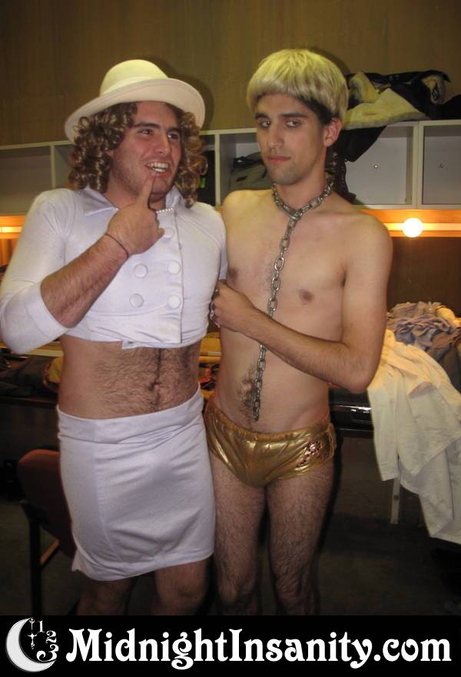
WARNER GRAND THEATER SAN PEDRO CA

