The Rules
2. No smoking in the theater (If you're just flaming, join cast).
2. This is an audience participation movie...
2. Do not throw anything at the stage, the screen, or the thespians.
2. If you have a penis, use the men's room. If you have a vagina, use the ladies room. If you've got both, piss on Waaade.
2. No double sitting in the seats.
2. Do not park in the parking lots after two. You might be towed.
2. This is an Rated-R movie. That means, if you're easily offended, we've got five words for you: Get The Fuck Out, Bitch.

San Pedro BrewHaHa.com Nov 6-18
AN HOUR OF STANDUP THEN A FUNNY FILM and BEER (Or Soda)
Nov 6 PRINCESS BRIDE
Nov 7 YOUNG FRANKENSTEIN (M-M-Madeline)
NOV 8 USED CARS (Kurt Russell, Lenny&Squiggy)
NOV 13 MONTY PYTHON LIFE OF BRIAN
Nov 14 HOLY GRAIL
Nov 15 THE HANGOVER (Mike Epps, Mike Tyson)
Nov 16 THIS IS SPINAL TAP (Lenny)
Nov 17 STAND UP COMEDY NIGHT-No film Yes Beer
Nov 18 NOISES OFF (Reeve, Ritter, Sheridan, Caine)
Need a CAR?
Ask for ROCKY HORROR Discount at
GardenaHonda.com
800-965-7571
Ask for Mark Tomaino
15541 S. Western Ave Gardena CA

Midnight Insanity
MAILING ADDRESS 2286 E. Carson St. #230 Long Beach CA 90813
(562) 235-8053 MidnightInsanity.com
E-mail: (cast member's name)@MidnightInsanity.com
Have Feedback on the show? E-mail Brandon@midnightinsanity.com
THEATER SHOW INFO: WarnerGrandShows.com

© Copyright Midnight Insanity Entertainment 1988-2009 and beyond
The Rocky Horror
Picture Show
Presented by

October 24, 2009 Show number 1,219

BRANDON’S NONSENSICAL DINING ROOM
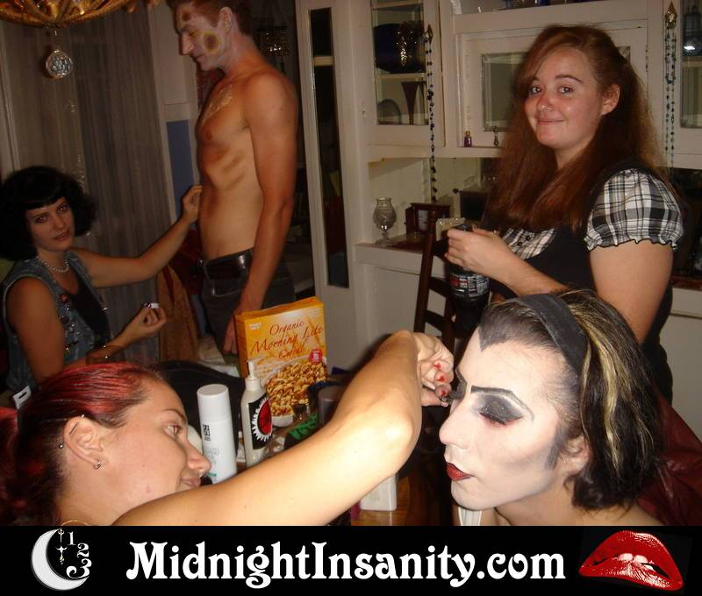
Colleen, Jason,Danielle, Diego and Jo prep for Vampire Zombie 10/3
WARNER GRAND THEATER SAN PEDRO CA

