The Rules
2. No smoking in the theater (If you're just flaming, join cast).
2. This is an audience participation movie...
2. Do not throw anything at the stage, the screen, or the thespians.
2. If you have a penis, use the men's room. If you have a vagina, use the ladies room. If you've got both, piss on Waaade.
2. No double sitting in the seats.
2. Do not park in the parking lots. You will be towed.
2. This is an Rated-R movie. That means, if you're easily offended, we've got five words for you: Get The Fuck Out, Bitch.
Buy This Stuff
Tranny Makeover Experience $5.00
Midnight Insanity T-shirts $10.00

Buy This Stuff Too
Need a CAR?
Ask for Rocky Discount at
GardenaHonda.com
800-965-7571
Ask for Mark Tomaino
15541 S. Western Ave Gardena

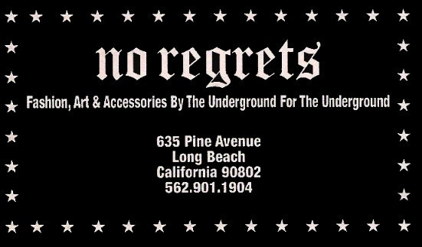

Midnight Insanity
2286 E. Carson St. #230 Long Beach CA 90813
(562) 235-8053
www.midnightinsanity.com
E-mail: (cast member's name)@midnightinsanity.com
Have Feedback on the show? E-mail Brandon@midnightinsanity.com

© Copyright Midnight Insanity Entertainment 1988-2009 and beyond

The Rocky Horror Picture Show
Presented by

9/19/2009 Show number 1,213


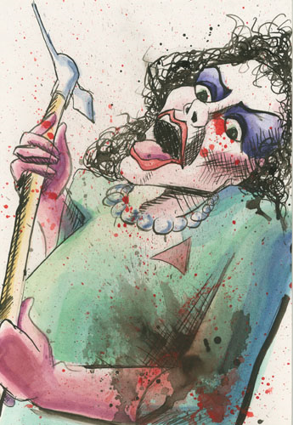
Warner Grand Theater San Pedro CA

