Tonight's Cast
Pre-Show Dan and Tracy
Trixie Sara Lee
Frank N. Furter Diego
Brad Majors Bill
Janet Weiss Sammie
Riff Raff Paco
Magenta Terry
Columbia CJ
Dr. Scott Tim
Eddie Mark
Rocky Jordan
Crim Larry
Phantom Dan

Transylvanians
Cheryl Ponchita Jesus Adam Sam
Ami Jordan Patti Andrew Peter Carlos

Midnight Mafioso
Producer: Mark Tomaino Assistant Producer: Brandon
Technical Director: Elfboy Webmaster: Bill
Tranny Coordinator: Cheryl Props Fox: Jo Terry
Lightboard: Gayson Photog/Secretary: Aleah
Merchandise: Christiana Security Czar Shevaun
Spotlights: Drew, Mit, Taylor, Kim, Leif
Tech: Alysha, Strayson, Zac, Tracy, Chris

V.I.S.C.I.O.U.S.
(Very Intimidating security Crew In Our Ubiquitous Service)
Shevaun Wade Beka

Denton Times

Thank you so much for coming to celebrate our 22nd Anniversary last week. We continue the fight into now our 23rd year together as a cast performing the same show every week. No end in sight and thank you for making it possible and for coming to play with us.

VALENTINES SHOW Will be 2/13. It is also PIMP AND HOOKER NIGHT so you know what to do. Dress your part. There will also be a special Valentines Lingerie contest that night because it is a good excuse to have one.

DARK MARCH 27 so do not show up for Rocky that night. March Lingerie will be the 20th.

Check WarnerGrandShows.com for other upcoming events.

MARCH 14 Sunday 6PM A comedy benefit for Haiti. We are helping to organize a benefit for Haitian Earthquake recovery. This will be a special night of tribute and also using laughter to help in this crisis. We need to use whatever means necessary to help and the comics want to do their part too. Please be here to help. In association with worldmindnetwork.net and haitiearthquakerelief.net

Go to MidnightInsanity.com to link up to our myspace, twitter, Facebook, Rocky Horror Yellow Pages list and see pix of yourselves each week.

Come play with us…ask any castmember how much fun that can be.
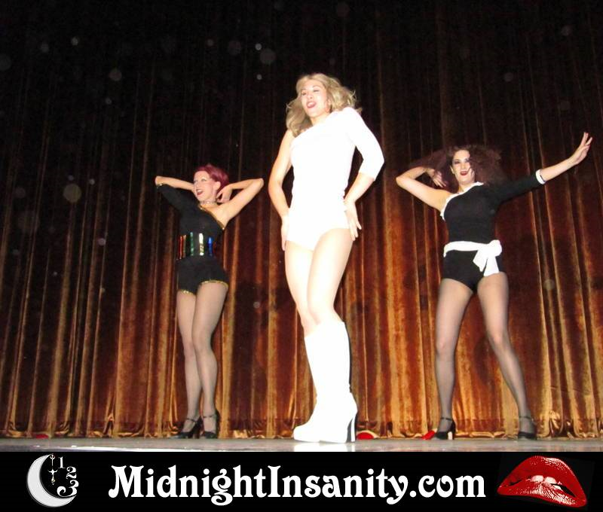
Scene from Filthy Gourgeous at Birthday show

